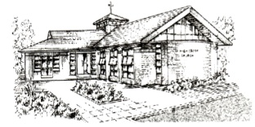
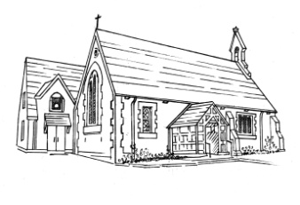
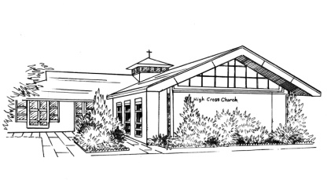
The PARISH of MUDEFORD

The Churches of All Saints Mudeford
& High Cross Somerford

Web site: www.allsaintsmudeford.org

Your privacy is important to us, and we want to communicate with church members in a way which has their consent, and which is in line with UK law on data protection. As a result of a change in UK law, we now need your consent to how we contact you. Please fill in the contact details you want us to use to communicate with you:
Name _____________________________________________________
Address: ___________________________________________________
___________________________________________________
Email Address: ________________________________________________
Phone Number: ________________________________________________
By signing this form you are confirming that you are consenting to the PCC of All Saints Mudeford holding and processing your personal data for the following purposes (please tick the boxes where you grant consent):-
I consent to the church contacting me by post phone or email.
☐ To keep me informed about news, events, activities and services at All Saints (note you can unsubscribe from the church e-bulletin at any time);
☐ To including my details in the ‘Church Directory’ which is circulated to the Churchwardens, Church Administrator, Clergy, Treasurer and Pastoral Ministry Team.

☐ To share my contact details with the Diocese of Winchester so that they can keep me informed about news, events, activities and services that will be occurring in the diocese and which are directly relevant to the role I am undertaking;

Signed: ______________________________ Dated: _______________________________
You can grant consent to all the purposes; one of the purposes or none of the purposes. Where you do not grant consent we will not be able to use your personal data; (so for example we may not be able to let you know about forthcoming services and events); except in certain limited situations, such as where required to do so by law or to protect members of the public from serious harm. You can find out more about how we use your data from our “Privacy Notice” which is available from our website or from the Parish Office.
You can withdraw or change your consent at any time by contacting the Parish Administrator at All Saint, Church Mudeford, email allsaintsmudeford@gmail.com . Please note that all processing of your personal data will cease once you have withdrawn consent, other than where this is required by law, but this will not affect any personal data that has already been processed prior to this point.

